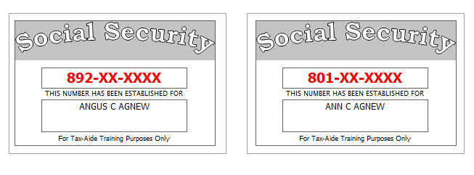
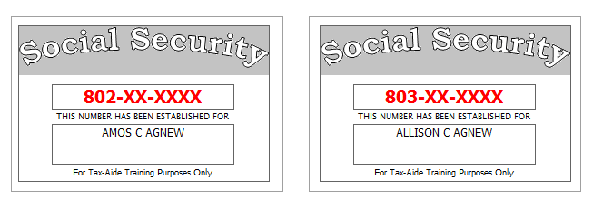
Interview Notes:
- The Agnews had $12,079 of unreimbursed medical expenses for the year.
- Health Insurance:
- Angus was covered by Medicare all year.
- Ann had coverage from a Marketplace policy all year.
- Ann’s employer did not offer medical coverage for her or her family.
- Amos and Allison had a Marketplace exemption for January 1 through May 31. Certificate numbers: Amos: A23DE1; Allison: A23DE2;
- Amos had coverage from an employer from August 12 through August 19. He had no coverage from August 20 to December 31. (For purposes of this exercise, assume there is no exemption applicable to Amos for this period.)
- Allison had coverage from CHIP from July 1 to December 31.
